Task 5: Style on HTML
### Applying Styles Directly to HTML Elements Using the `style` Attribute

You can apply styles directly to an HTML element using the `style` attribute. This approach embeds CSS rules within the HTML tag itself. Inline styles are useful for applying specific styles to individual elements without using external or internal CSS.

### Example HTML Document with Inline Styles
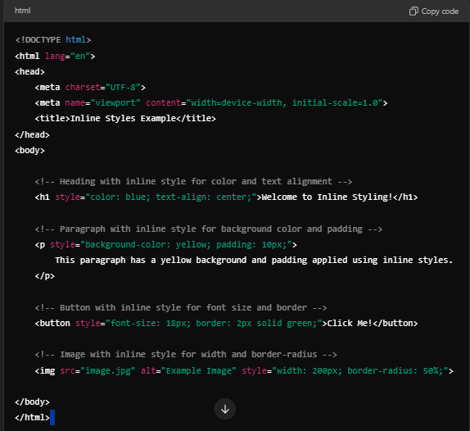
### Explanation:
- The `style` attribute is used within HTML tags to apply CSS rules.
- Each property is written in the format: `property: value;`.
- Example:
- The `<h1>` tag has the styles `color: blue;` and `text-align: center;` applied directly, making the heading blue and centered.
- The `<p>` tag has `background-color: yellow;` and `padding: 10px;`, which gives the paragraph a yellow background and spacing inside.
- The `<button>` has `font-size: 18px;` and `border: 2px solid green;`, increasing its font size and adding a green border.
- The `<img>` has `width: 200px;` and `border-radius: 50%;`, making the image a circular thumbnail with a fixed width.

---

### Pros and Cons of Using Inline Styles

#### **Pros:**

1. **Quick and Easy for Small Edits**:
- Inline styles are great for quick, small changes to a single element without creating or modifying CSS files.

2. **Overrides External and Internal Styles**:
- Inline styles have the highest specificity in CSS, meaning they override both external and internal stylesheets.

3. **Useful for Email Templates**:
- Many email clients strip out external styles, so inline styles are often required in HTML emails to ensure proper formatting.

4. **Immediate Feedback for Debugging**:
- They are useful when testing or debugging because you can see the effects of a style immediately.

#### **Cons:**

1. **Hard to Maintain**:
- Inline styles scatter styling rules across multiple HTML elements. As a result, it becomes hard to maintain and update styling, especially on large projects. Every change must be manually updated in each element.

2. **Lack of Separation Between Structure and Style**:
- One of the core principles of web design is to separate structure (HTML) from presentation (CSS). Inline styles violate this principle by embedding presentation rules directly into the HTML, leading to cluttered and hard-to-read code.

3. **Redundancy and Code Duplication**:
- If the same styles are needed on multiple elements, inline styles result in duplicated code. External stylesheets allow you to define a rule once and reuse it.

4. **No Media Queries or Pseudo-classes**:
- Inline styles cannot handle advanced CSS features like media queries (for responsive design) or pseudo-classes (like `:hover` or `:focus`).

5. **Poor Performance**:
- Embedding styles within each HTML element increases the file size, especially if repeated across many elements. Using external stylesheets helps keep the HTML file size smaller, making the page load faster.

---

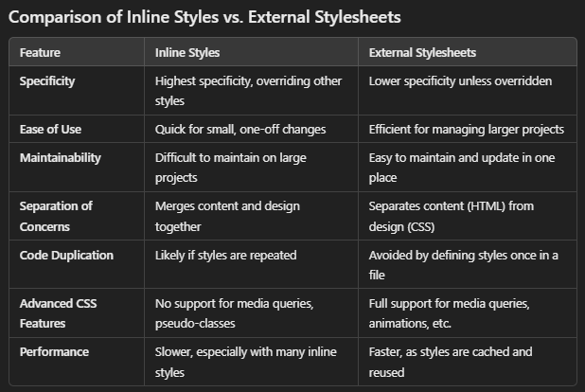
### Conclusion:

- **Inline styles** are best for quick, one-off style changes or in situations like email templates where external styles may not be supported.
- **External stylesheets** are preferred for larger, maintainable projects where styles need to be reused and managed in one place, keeping the HTML clean and easy to read.

By understanding the trade-offs between inline and external styles, you can choose the most appropriate method for your specific needs.

